Onboarding Process Flow-Ford Internal

Step 1:
New Supplier:
Follow the below steps.

- Step - 2
- Step - 3
- Step - 4
- Step - 5
- Step - 6
- Step - 7
- Step - 8
Additional Users:
For adding additional users for the existing GSDB code. Follow the below steps.

- Step - 9
- Step - 10

On Boarding Request for WebEDI Users

Step 2:

If this supplier is new to Ford and does not have a GSDB code:

Establish GSDB code for company implementing EDI with Ford. Supplier will contact their Ford buyer to obtain a supplier code (GSDB) which will identify your company to Ford.

Suppliers can refer to the EDI Connectivity Requirements Document to review the connectivity options available.

Additional information on the EDI process is available on the
Global Supplier Database Homepage

Step 3:

If the supplier requires a connection to GECHub through WebEDI, then follow the subsequent process.

Step 4:
The supplier organization will require access to Covisint and Ford Supplier Portal (FSP) before registration in GSDB Online.

Suppliers can contact SUPLHELP@FORD.COM for Covisint/FSP registration assistance.

Registration process for FSP/GSDB Online– Ford Motor Company

4.1. Registration in FSP
4.1.1 In this step, the company registers in Ford Supplier Portal (via Covisint)

https://us.register.covisint.com/start.html

If you do not come to a screen with “Welcome: Covisint Registration” at the top, try https://us.register.covisint.com/CommonReg?cmd=REGISTER

Select New Top-Level Organization, click “Begin registration”.
Read the administrator role information, click “Accept administrator role”.
Fill in the company information (orange fields are required, others are optional), click “Continue registration”.
Fill in the information for the administrator (again, only orange fields are required). Choose your own User ID and password. The password must be at least eight characters and contain one number.
Click “Continue registration”.
Select Ford Supplier Portal as the service package (in the Partner Portals section of the services list)
Click “Continue”.

Enter your four-character GSDB code as your site code, and click “Continue registration”.
Review the Ford Supplier Portal SAO Information and click “Yes, I accept the agreement”.
Review the information and click “Submit registration”

You should receive a “Successfully submitted” notification on your screen.

4.2. Registration in GSDB Online
Suppliers can contact GSDBWEB@Ford.com for assistance on GSDBOL registration.
Once the company obtains approval for access to FSP, the CSA must register for GSDB Online. There are two steps to this part of the process:

- The CSA must give him/herself access to FSP
- The CSA must fill in the GSDB Executive Sponsor form

4.2.1 The CSA can grant him/herself access to FSP by:

Go to http://www.covisint.com and log in
Click on Administration tools (left side of the screen)
Click on view profile in the my profile section (left side of the screen)
In the blue options section, click add service package
Ford Supplier Portal (FSP) / GSDB On-line Registration

Look in the Partner Portals section for Ford Supplier Portal. Click the “Add” button.
The next page describes what is contained within the Ford Supplier Portal. Click “Continue”.
When asked to pick a site code, choose the four-character parent code and click “Continue”.
Read the terms and conditions, and click “Yes, I accept”.
If required, continue through the menus until you receive a message stating the package is successful.

4.2.2 Once you have access to FSP, the GSDB Executive Sponsor form can be filled out (if your company has been authorized to fax in a paper copy of this form, skip this step):
Go to the site:
https://web.fsp.ford.com/PerlMigrationWeb/jsp/gsdbOnlineIntroduction.jsp

Enter your FSP (Covisint) User ID, and click “Begin Registration”.
Fill in all of the information. Do not add characters such as the “ ‘ “ in O’Hara or hyphens to names. For phone numbers, do not use anything other than digits (ext or x can be used for extensions). Note that the Executive Sponsor must be the CEO, President, or VP of Finance (CFO, COO are acceptable). If you are the Executive Sponsor, put your correct email address in the Executive Sponsor section and a different email address in the CSA section. The system will not allow both to be the same.
Click “Submit Nominations”.

It is important to let the Executive Sponsor know the following:

Two e-mails sent to the Executive Sponsor; one has a link to a website, the other a PIN code.
The Executive Sponsor needs to go to the website, enter his/her last name, PIN code, and click “Next”. The Executive Sponsor must then answer the four questions to approve the CSA. If the Executive Sponsor does not receive both emails within 48 hours, send a note to GSDBWEB@ford.com with the company name and GSDB code.

4.2.3 After filling out the GSDB Executive Sponsor form, create at least one additional user. To create another user:
https://us.register.covisint.com/start.html

If the screen does not have “Welcome: Covisint registration” at the top, try https://us.register.covisint.com/CommonReg?cmd=REGISTER
Select New User, click “begin registration”

Ensure the drop down for “Enter the organization name” says “contains,” then enter the organization name, and click “Search”.

Select your company, and click “Continue registration”.
Fill in the user information (orange fields are required). If any of the information needs to be changed, change it. DO NOT use the same email address as another User ID. Choose a User ID and password. The password must be at least eight characters and contain one number.
Click “continue registration”.

Select Ford Supplier Portal as the service package (in the Partner Portals section of the services list), and click “Continue”.

Enter your four-character GSDB code as your site code, and click “Continue registration”.
Read the terms and conditions, then click “Yes, I accept agreement”.
Review the information and click “Submit registration”.

The company CSA (administrator) must approve the request for the new user ID (see next step).

4.2.4 The CSA can approve a new user by:
CSA logs in (using CSA's ID) to www.covisint.com.
Click on Administration tools.
Click on user requests.
See the user's ID, and click on approve in full (or reject in full) and submit
Continue until you receive a success message and/or are returned to the pending requests screen.

Important note about setting up GSDB Online tokens: Organizations must have at least two people set for GSDBOL to work properly. One user must have the GSDBOL Email token and a different user must have the GSDBOL Update token. This ensures a check and balance for any updates made to the supplier’s information in GSDB Online.

Step 5:
Supplier CSA request Covisint WebEDI (Ford Supplier Portal sub-package) to get Covisint WebEDI application access.
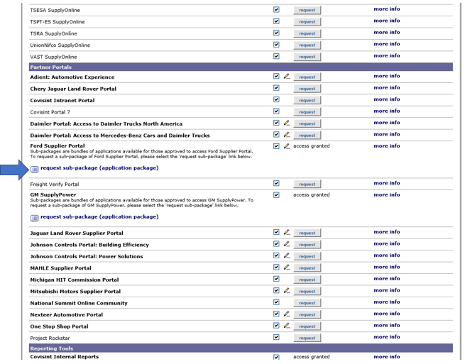

Step 6:
Setup the supplier for access to Covisint WebEDI:
The CSA will create a CRT ticket to Covisint and send to:
support@covisint.com

The subject line should read:

Covisint WebEDI Registration for Ford <supplier, GSDB code>

The contents of request should consist of:
<Type of request>
- New supplier and User
<GSDB code>
<Ship-from GSDB>
<Ship-to GSDB code(s)>
<Covisint userid or FSP userid (if not new)>
<Company name, full address (street, city, state, country, postal code), contact email and contact phone>

(SLA – 3-5 Business Days)

Step 7:
Covisint will send an email to econnect@ford.com that includes all the same details.

Step 8:
AM to complete the setup in B2Bi under Covisint.

(SLA – 1-8 Business Days)

Step 9:
Add additional users.

9.1 To register as a new user:

https://us.register.covisint.com/start.html;

If you do not come to a screen with “Welcome: Covisint Registration” at the top, try https://us.register.covisint.com/CommonReg?cmd=REGISTER
Select New User, and click “Begin registration”.
Make sure the drop down for “Enter the organization name” says “contains,” then enter the organization name, then click “Search”.
Select your company, and click “Continue registration”.
Fill in the user information (orange fields are required). If any of the information needs to be changed, change it. DO NOT use the same email address as another User ID. Choose a User ID and password. The password must be at least eight characters and contain one number. Click “Continue registration”.
Select Ford Supplier Portal as the service package (in the Partner Portals section of the services list), and click “Continue”.

Enter your four-character GSDB code as your site code, then and click “Continue registration”.
Read the terms and conditions, click “Yes, I accept agreement”.
Review the information and click submit registration.

The company CSA (administrator) must approve the request for the new user ID (see next step).

9.2 The CSA can approve a new user by:
CSA logs in (using CSA's ID) to www.covisint.com.
Click on Administration tools.
Click on user requests.
See the user's ID, and click on approve in full (or reject in full) and submit.
Continue until you receive a success message and/or are returned to the pending requests screen.
Supplier CSA also does Step 10.
Step 10:
Notify the Covisint Onboarding team to Setup the supplier for access to Covisint WebEDI:
Supplier CSA will create a CRT ticket to Covisint and send to:
support@covisint.com

The subject line should read:

Covisint WebEDI New User Registration for Ford <supplier, GSDB code>

The contents of request should consist of:

<Type of request>
- New user to existing supplier
<GSDB code>
<Covisint userid or FSP userid (if not new)>
<Company name, full address (street, city, state, country, postal code), contact email and contact phone>

(SLA – 3-5 Business Days)

