How to register aS A USER for Ford Supplier Portal (FSP) access
This document provides instructions for how supplier personnel that require access to applications or links provided via the Ford Supplier Portal (FSP) can register for Covisint and FSP access.

Registering as a user for Covisint and the Ford Supplier Portal (FSP)

In order to be able to register as a user for Covisint and FSP access:
- Your organization must already have Covisint access and an active Covisint Corporate Security Administrator (CSA).
- You must know one of your organization’s Ford Global Supplier Database (GSDB) supplier codes. If you are unsure of your organization’s GSDB code(s) please contact your organization’s Ford Account Representative or your Ford Buyer.
This document will provide the instructions for users who:
- Do not have access to either Covisint or FSP
- Already have access to Covisint, but not to FSP
- Need to know who to contact for help
Instructions for registering for user access to Covisint and FSP:
- Go to https://us.register.covisint.com/CommonReg?cmd=REGISTER.

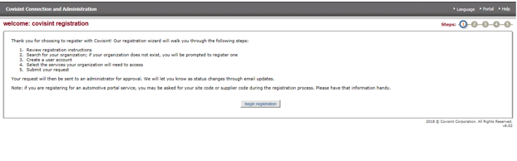

- Click on ‘Begin Registration’.
- On the following screen, identify the organization you need to register under by either providing the company name or supplier code (GSDB code).
  - Using Company Name (upper section of the screen): Enter a portion or the complete name of your company in the ‘enter organization name’ box at the top of the screen.
  - Using the supplier code – recommended (lower section of the screen):
    - Select 'Ford Motor Company (Ford Supplier Portal)' from the drop down options.

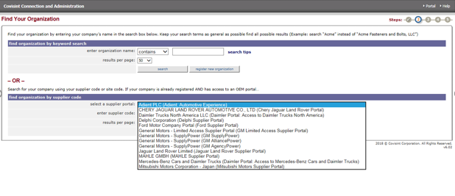

    - Enter one of your organization’s supplier codes (GSDB code) in the ‘enter supplier code’ field ID.

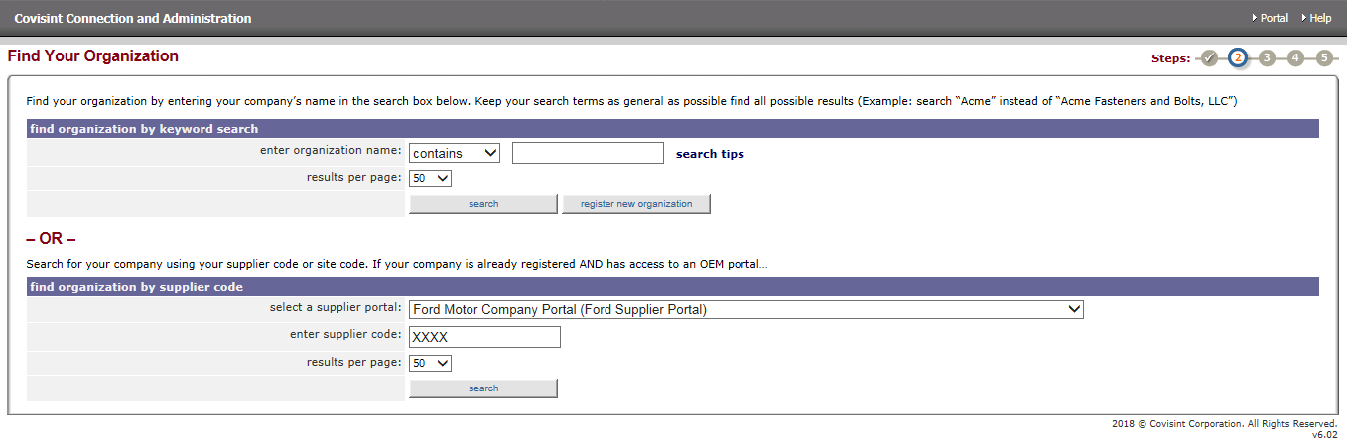
- From the returned results either:
  - Select the appropriate organization from the search results and click ‘continue registration’.
  - Do a new search because the results did not return the name you were looking for.
- On the ‘enter user information’ screen enter your data making sure to complete all required fields, which are designated by an *. When complete, click on ‘continue registration’.
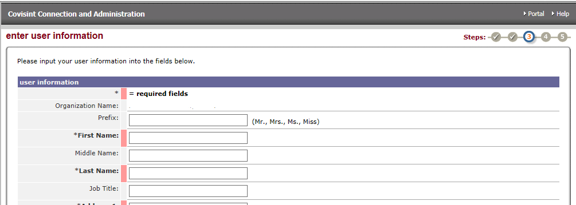

- The next screen will require you to:
  - Create your Covisint ID. Note the requirements for the ID shown on the screen.
  - Create your Covisint password.
  - Create your Challenge Question and Challenge Answer. This information will be used in the event you need to use the ‘Forget my password’ link on the Covisint sign-in page.
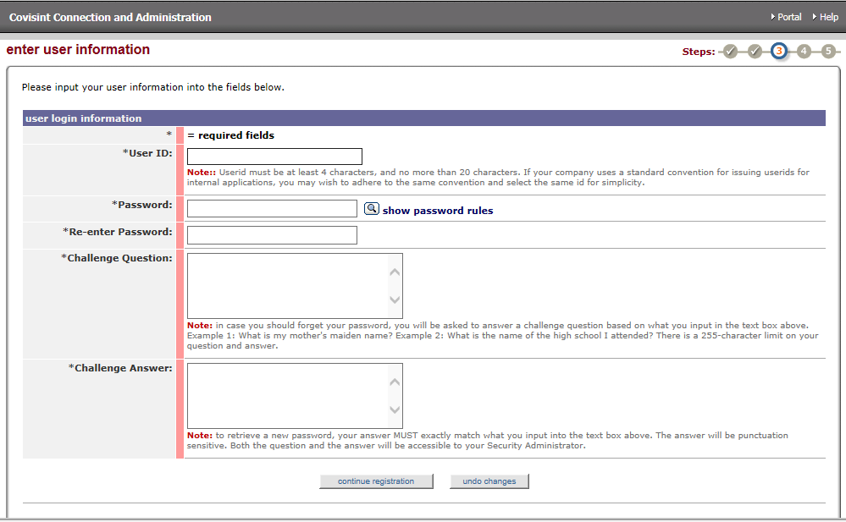
- When you have completed all required fields click ‘continue registration’.
- The ‘select service package(s)’ screen will display. Select ‘Ford Supplier Portal’ option under the ‘Partner Portals’ section.

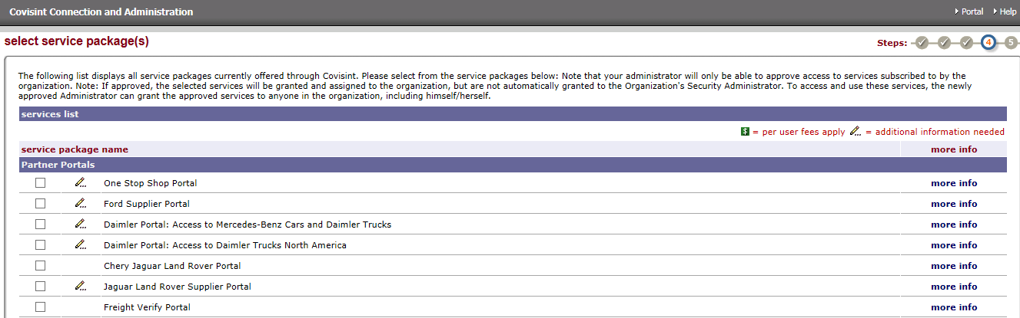

- Put a check in the check box next to the ‘Ford Supplier Portal’ and click the ‘continue’ button at the bottom of the screen.
- The ‘Enter location code for Ford Supplier Portal’ screen will display. Enter one of your organization’s four or five character supplier codes (GSDB codes) in the ‘enter home site code’ field and click ‘continue registration’. The ‘home site code’ your select should reflect the division or location that best represents what area of your company you are associated with.

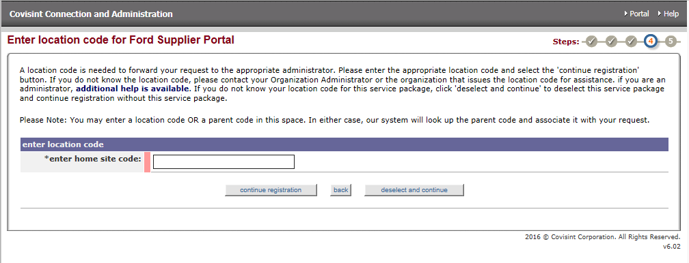
- Click ‘continue registration’
- The ‘Covisint Terms and Conditions for the use of the Ford Supplier Portal’ will display.

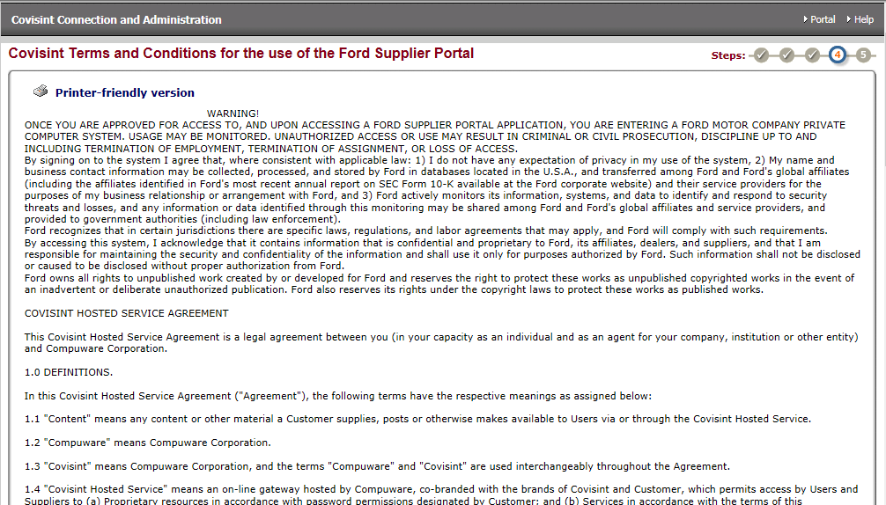
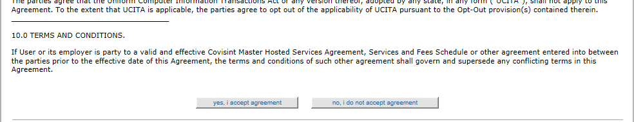

- Once you have reviewed this information click on ‘yes, I accept agreement’. The ‘review request and submit’ page will display.
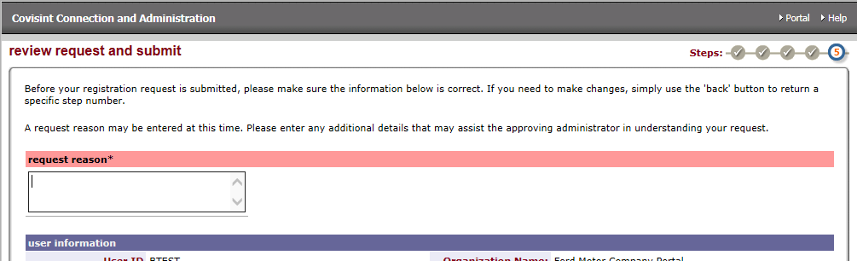
- Enter why you require this access in the ‘request reason’ field. This information will be displayed to your organization’s Covisint CSA, who will need to review your access request. Once you have reviewed the user information to ensure accuracy, click ‘submit registration’.
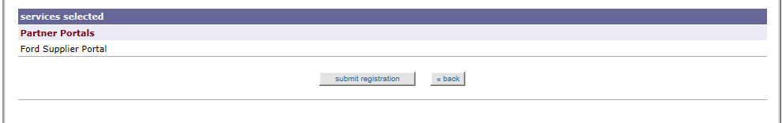

- The ‘you have successfully submitted your registration request’ screen will display indicating that the request process has been completed.
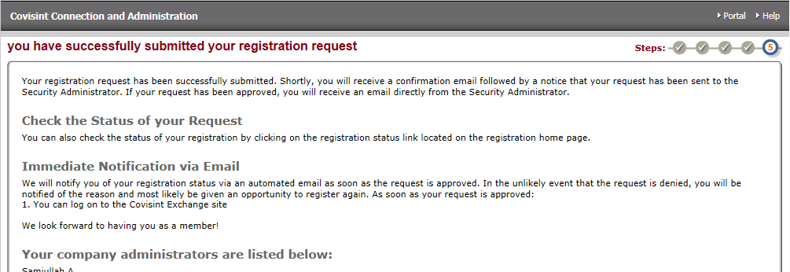
- Your request will be immediately visible to your organization’s Covisint CSA. Once they approve your request you will be notified by Covisint.

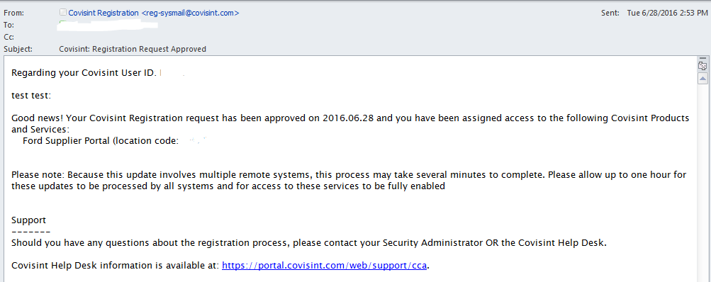

The following instructions are users that already have Covisint access for other Covisint portals or services.

- Sign into Covisint and select ‘Administration Tools’
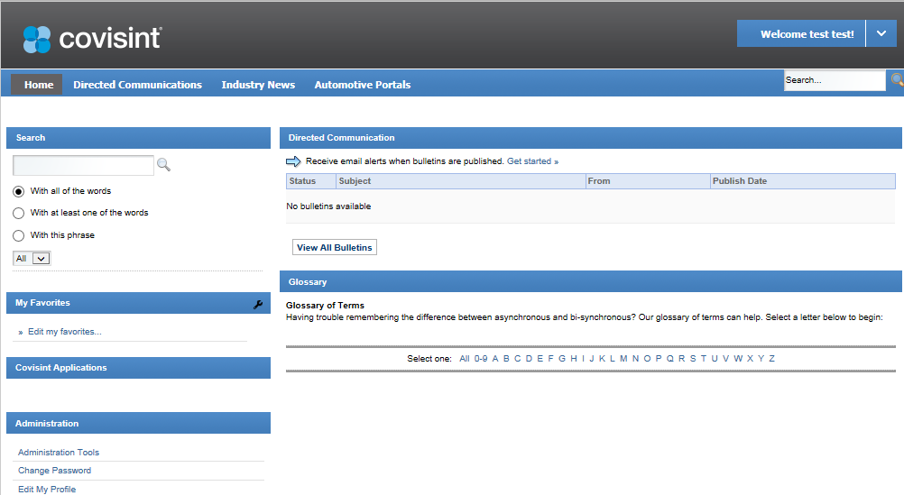

- When the ‘Covisint Connection and Administration for: (user name) displays, select ‘Request a Service Package’
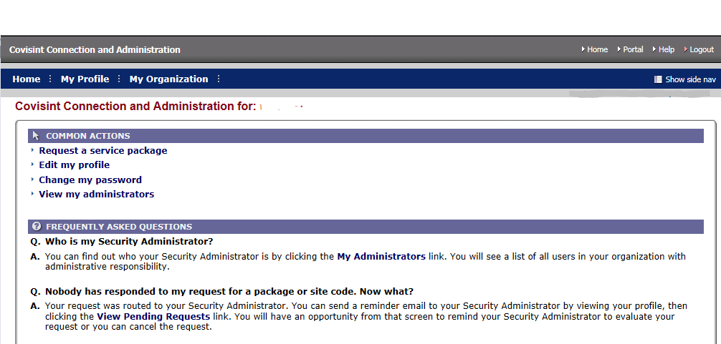

- When the ‘request service package: (user name)’ screen displays scroll down to the ‘Parent Portals’ section and click on the ‘request’ button on the ‘Ford Supplier Portal’ line.

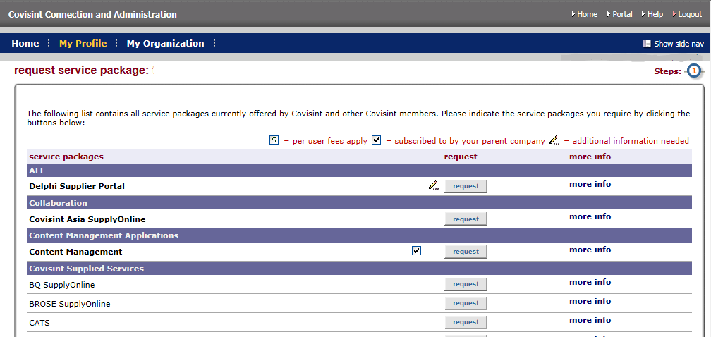

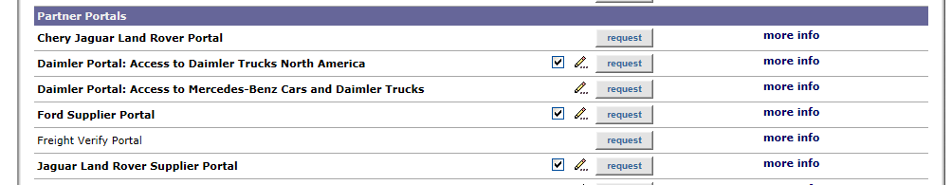

- The ‘request service package: Ford Supplier Portal for (user name)> review package details’ page will display showing all the applications that are included in FSP access. 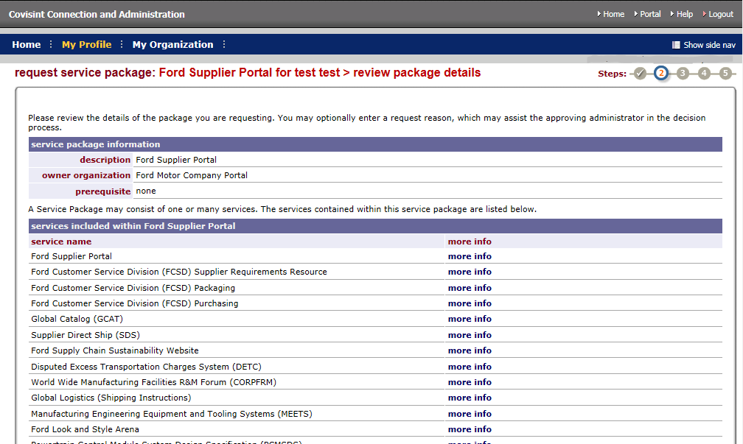
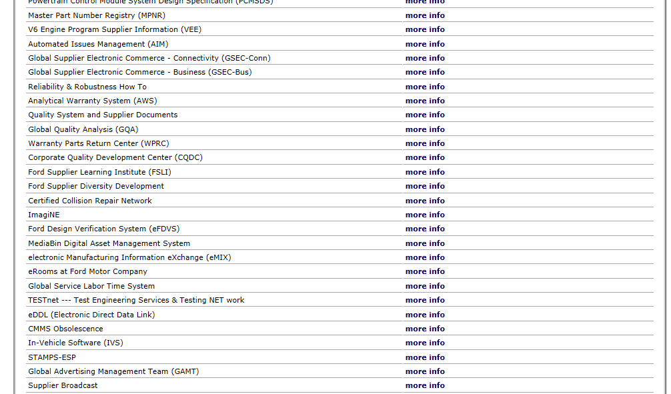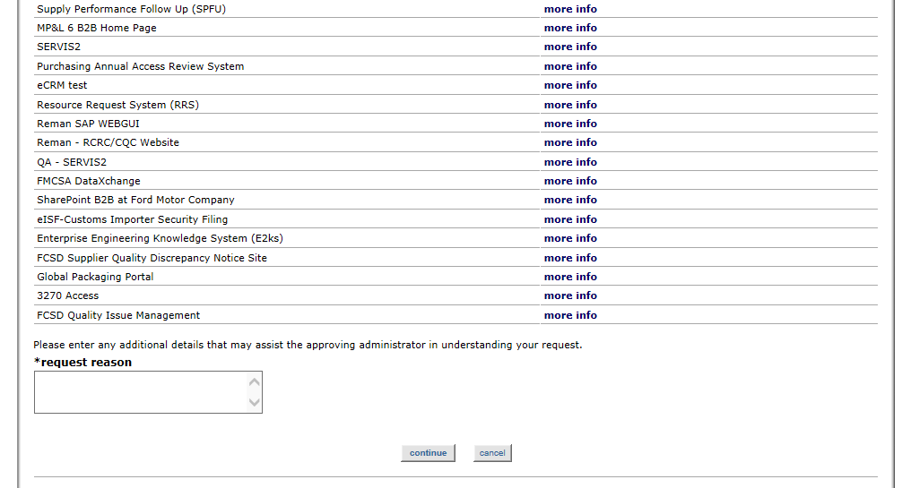
- Scroll to the bottom of this page, enter the required ‘request reason’, the ‘request reason’ will be displayed to your organization’s Covisint CSA with your request, and click ‘continue’.
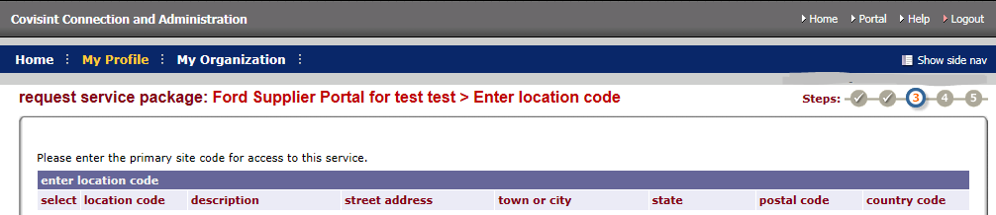
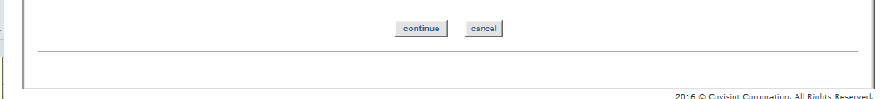
The ‘request service package: Covisint Terms and Conditions for use of the Ford Supplier Portal’ screen will display. Once you have read this page click ‘yes, I agree’.
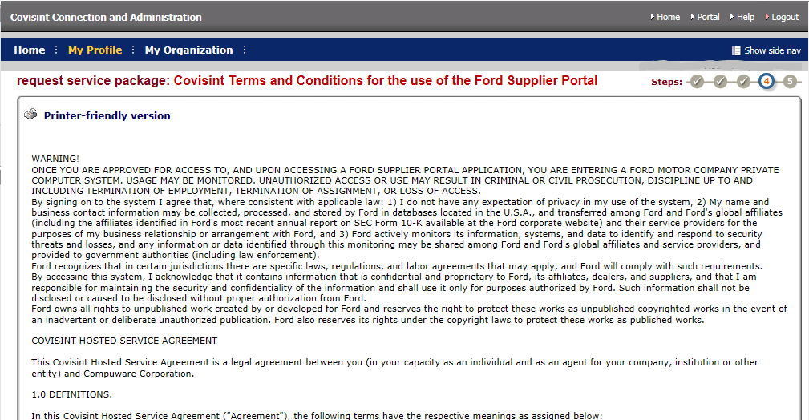
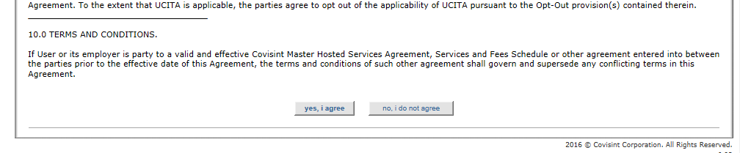
- The ‘request service package: Ford Supplier Portal for (user name)> Request Successful!’ page will display completing request process.
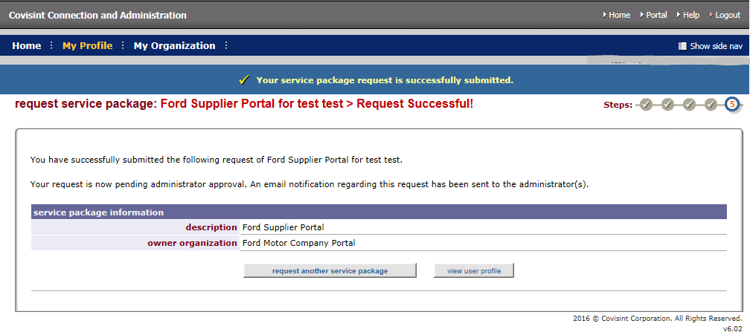
- You will receive an email from Covisint regarding your submitted request.
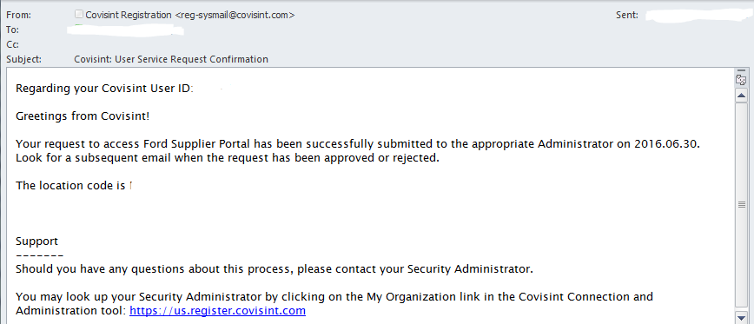
- Your organization’s Covisint CSA will also be notified about your submitted request. Your service package request for FSP will be immediately available to your CSA to review and approve after your submission.

- Once your CSA has approved your request you will receive a notification from Covisint and FSP will be available for your access.
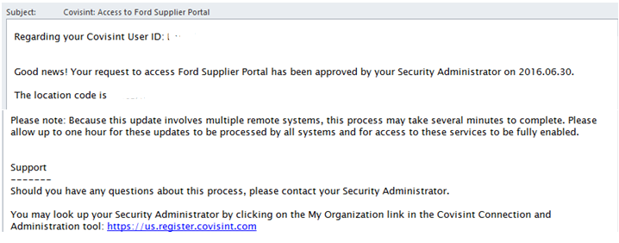

Where to go for help:
If you need help with your FSP registration you can send an email to SUPLHELP@Ford.com or contact the Ford Help Desk at one of the numbers below:
US and Canada 1-888-31-74957 | Colombia +58-241-874-6123
Argentina +54-11-47569898 | Germany +49 (0)221 9013322
Australia +61 3 9359 8686 | Indonesia +62-21-2758-8375
Brazil +55-11-4174 8400 | Mexico +52-55-1103-3930
Chile +56-2-9405860 | Philippines +63-49-5415155
China-Beijing +86-10-8507-0818 | Thailand +66 (0)2-686-5999
China-Nanjing +86-25-5118-7818 | UK +44 (0)1277 253322
China-Shanghai +86-21-3858-1818 | Venezuela +58-241-874-6123
For all other countries +1-888-31-74957

If you need help accessing the Covisint registration link, using the Covisint Application Tools functions or completing your Covisint or FSP registration, contact the Covisint Help Desk at one of the numbers shown below:
Argentina 0800.666.0367 | Malaysia 800 80 7658
Australia 1.800.787.355 | Mexico 001800.903.2588
Austria 0800/ 291488 | Netherlands 0800/ 9494612
Belgium 0800/ 999 85 | Poland 00800 1112095
Brazil 0.800.891.6002 | Portugal 800/ 781 400
Canada 866.273.5038 | South Africa 0801110217
China - North 10800 1301 550 | Spain 900/ 973 274
China - South 10800 713 1590 | Sweden 20109150
France 0800/ 91 68 77 | Taiwan 00801 14 8417
Germany 0800/ 1860092 | Thailand 001.800.1.3.200.4876
India 000-800-0016725 | Turkey +49 (0)6142/1621727
Italy 800/ 780424 | UK 08007/ 834 347
Japan 0066.33.821497 | USA 866.273.5038
Korea 0807810883 | Venezuela 0800.100.5987

