Entering Tooling Details
Entering Tooling Lines is an optional function for suppliers.
- Start by selecting the link to fill the Production Quote Details.
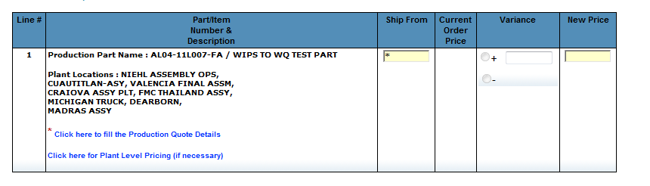
- After completing the Production quote information (and Auto Materials, if necessary), select the Tooling tab.
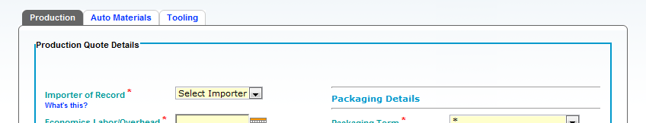
Some suppliers are required to complete more tool-related details than others at this point.
If you see this screen, you are required to provide detailed tool information. Please proceed to page 4 for instructions:
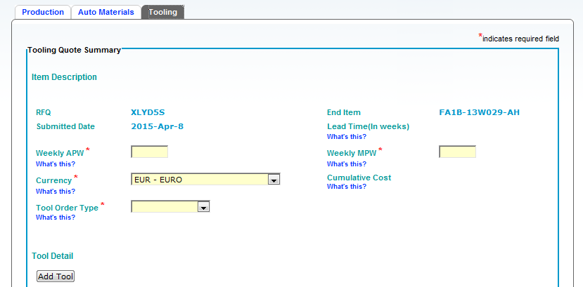
If you see the following screen, please continue with the instructions to follow:
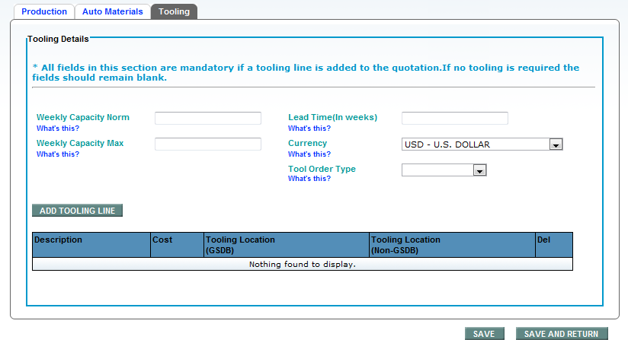

Entering Tooling Information Requiring Less Detail
Entering Tooling Lines is an optional function for suppliers, and can be done by using the Tooling Details tab from the quote screen.
- Start to create the Tool Order by completing the fields Weekly Capacity Norm/Max, Lead Time, Currency, and Tool Order Type. These fields are mandatory if you create any tooling lines, and these fields apply to the entire tool order – consider it "header information" for your tool order. Currency defaults to the RFQ currency, but can be changed here for your tool order.
- Click [ADD TOOLING LINE].
- For the first tool, complete these fields.
  - Description – the clear, concise description of your tooling component.
  - Cost – the cost of this line. Decimals are not allowed.
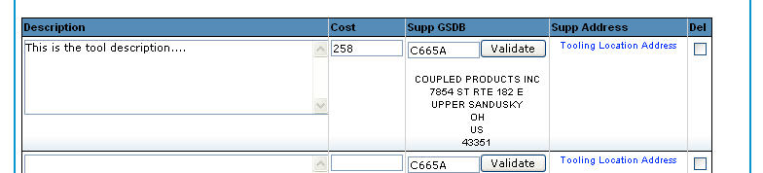
  - Supp GSDB – the 5-digit supplier code where this tool physically resides. Enter the code, and use the [Validate] button to validate that it is an active code and populate the location address. The address information from GSDB will populate if it is a valid code.
  - Supp Address – the physical address where the tool will reside. If the address shown in the Supp GSDB field is not the address where the tool will reside, use click on Tooling Location Address to enter the address information. Using this field is not required if the "validate" function in the Supp GSDB field has the correct information.
  - Del – a checkbox that allows the user to delete a line if necessary.
- Click [SAVE] once the line is complete. A confirmation message is displayed at the top of the screen.
- If more than one Tooling Line is needed, click on [ADD TOOLING LINE] and repeat the above steps. The Total Cost displayed at the bottom of this screen is a cumulative total of all Tooling Lines.
- Click [SAVE AND RETURN] once you have entered all necessary tooling. The Quote screen displays.
Entering Tooling Information Requiring More Detail
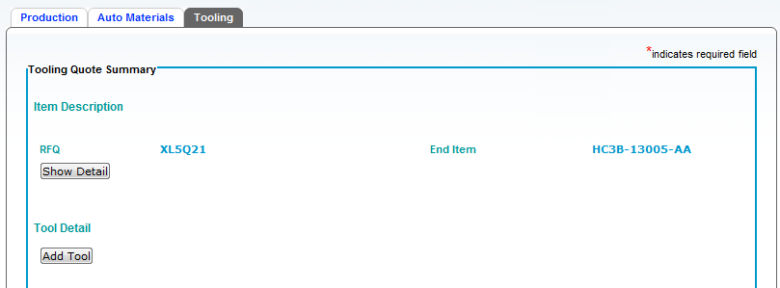
- Click [Show Detail] to enter the Weekly APW and Weekly MPW. Select the correct Currency if the default needs to be changed. Select the correct Tool Order Type:
Long Lead
Job 1
Design Change
Capacity
Other
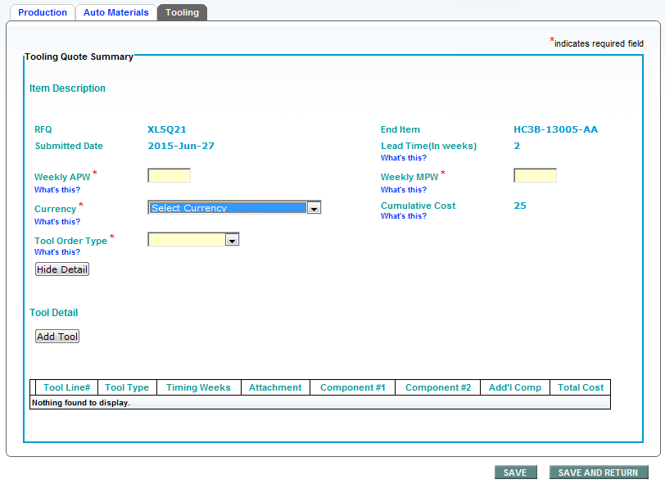
- Click [ADD TOOL] to start the itemized tool list.
- For the first tool, complete these fields.
Note: Fields marked with * are mandatory fields.
  - Tool Type – select from a list of tool type descriptions. Then select from a more specific tool type list dependent on your first selection.
Injection Mold
Stamping
Castings
Assembly Fixture
Bonding
Coatings
EOAT
Gauge
Machining
Part Treatment
Punch / Trim
Skin Lamination
Verification
Experimental
Other (*Add manually)
  - Total Parts Produced/Cycle - total parts produced per cycle for all components.
Note: Total Parts Produced/Cycle of all individual components must match this entered total
  - Timing Weeks - lead time, in weeks, for buying and installing the tool
  - Total Cost/Tool - cost of the tool in the currency selected
  - Notes/Comments – Suppliers must enter detailed tooling description here. (Use this section for any additional description information that needs to be communicated and available on the tool order as this information will be included on the actual tool order.)
  - Component NO/Desc - select from a list of components. See page 8 for instructions on how to add a component, if the proper component is not listed.
  - CAD File Rev - indicate which CAD file revision this tooling supports
  - Parts Produced/Cycle - parts produced per cycle for this particular component
  - Toolmaker E-mail - e-mail address of toolmaker.
  - Toolmaker Phone - phone number, including country code, of toolmaker.
  - Supplier E-mail - e-mail address of Supplier contact person.
  - Supplier Phone - phone number, including country code, of supplier.
  - Tier Using Tool - indication of which Supplier tier is using the tool.
  - Tool Location (Supp GSDB) - GSDB code for the location at which the tool is installed and used. WebQuote will display the location below, once the GSDB code is confirmed by clicking [VALIDATE].
  - Tool Location (Supp Non-GSDB) - use this link to type the address where the tool is installed and used if no GSDB code has been assigned to it.
  - TBS Attachments - Supplier may attach any appropriate documents applying to this tool.
- To add a second component, click [Add Component] again. You will have a second box to start selecting component information.
Note: Total Parts Produced/Cycle of all individual components must match this entered total

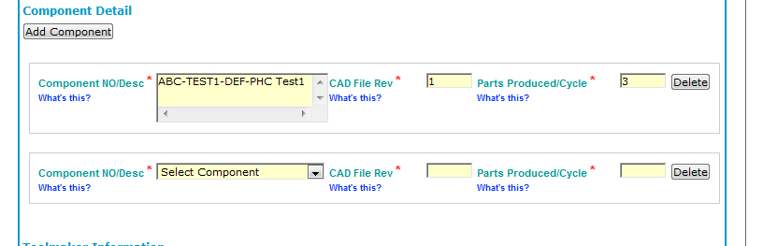
- If information on a component is incorrect, click [Delete].
- If you are completed with your components and you have additional tooling to add, click [SAVE]. You may view or edit the information, or delete the tool line.
- If you have no other tooling to add, click [SAVE AND RETURN].

Adding Components Manually
To follow are instructions for manually adding a component if the component list does not include the right choice:
- Select the Search option as shown, and then click [Search].
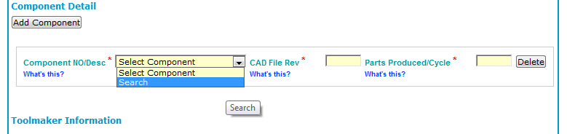
- Enter complete or partial part number and click [Search].
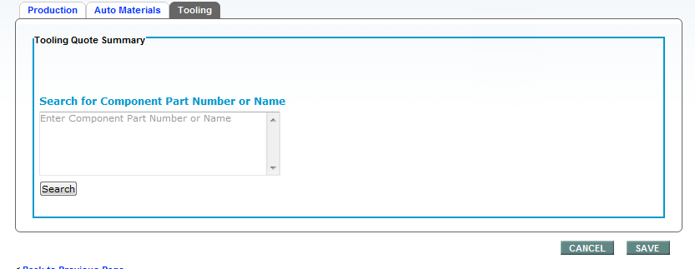
- Select the correct part number from results list and click [SAVE].
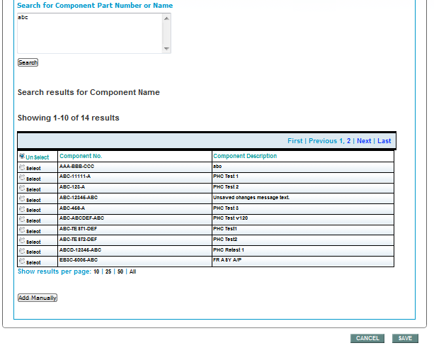
- If the correct part number is not available, click Add Manually. Complete all entries and click [SAVE].
Note: This entry will be flagged to the buyer as a manually added component.
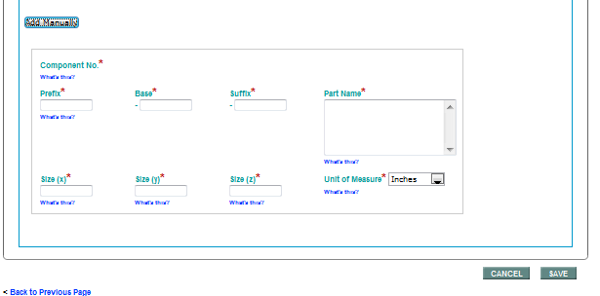
- Once this component is completed, click [Add Component] to add additional components for the tool. If all components are added, click [SAVE].

