WebQuote changes for the CPA Process
The CPA in WebQuote contains two parts which make up the CPA, the CPA RFQ/Quote and the CPA Order. Only after completing both parts will the CPA submission be considered competed.
Currently in WebQuote when receiving a CPA, the user first fills out the quote and after this is submitted, the system takes you to the order to either “Accept CPA” or “Respond with Quote Only”. As of today, we have reversed the process in the system to first take the user to the Order to “Accept CPA” or “Respond with Quote Only”. Clicking the appropriate button from the order page has the following result:
- Accept – Accepts the CPA which completes the Action. The supplier will not be able to send a quote back after they click Accept CPA.
- Respond with Quote Only – Allows the supplier to send the quote information back the buyer, once the user clicks Respond with Quote Only they will be prompted to go to the quote screen which allows them to fill out the quote and submit it to the buyer.
Here are some screenshots for the new process.
Supplier is made aware of the CPA by either receiving a system email or seeing it on the Homepage under Open Requests. The navigation now will take you directly into the CPA Order when clicking the link in the RFQ Number column.

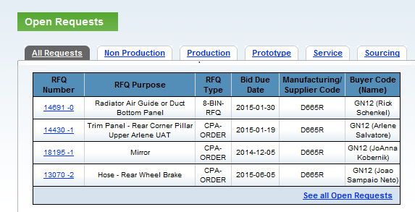

The user is expected here to fill in their job title and click the Accept CPA button or Respond with Quote Only Button. Clicking the Accept the CPA button will complete the action for the supplier and the system will provide the message below. As it states, a quote will not be allowed for an Accepted CPA.
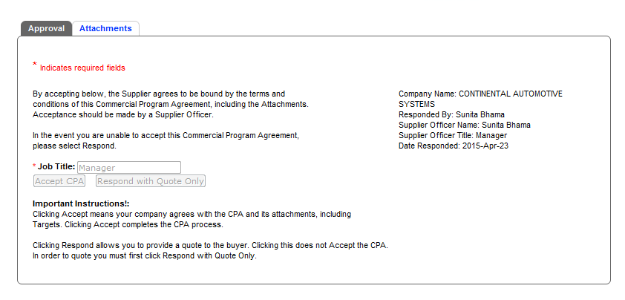

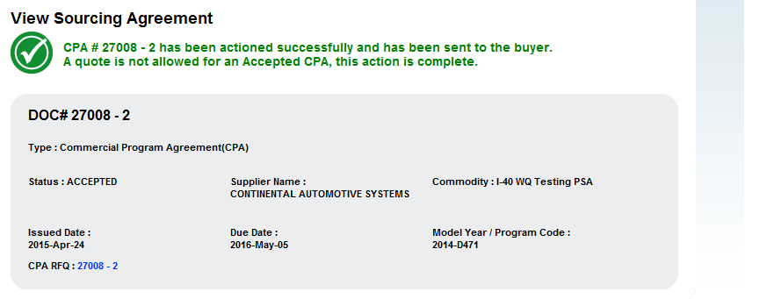

Clicking Respond with Quote will provide the following message and prompt the user to click the link which navigates them to the Quote screen. This will allow the user to provide a quote and submit it to the buyer. Acceptance of this CPA could then occur in the future via WebQuote when the buyer creates a new iteration of this CPA that would go back to the buyer for a response.

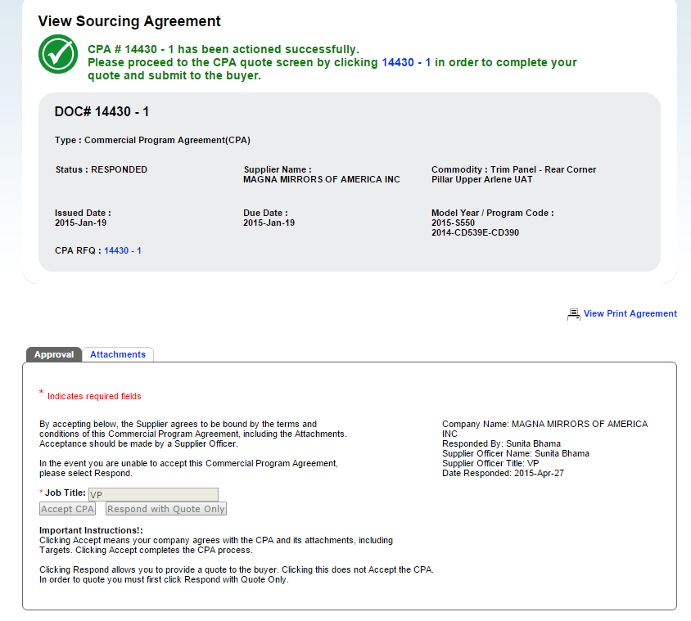

Fill out the quote as appropriate (mandatory fields are in yellow) and then click continue to submit.
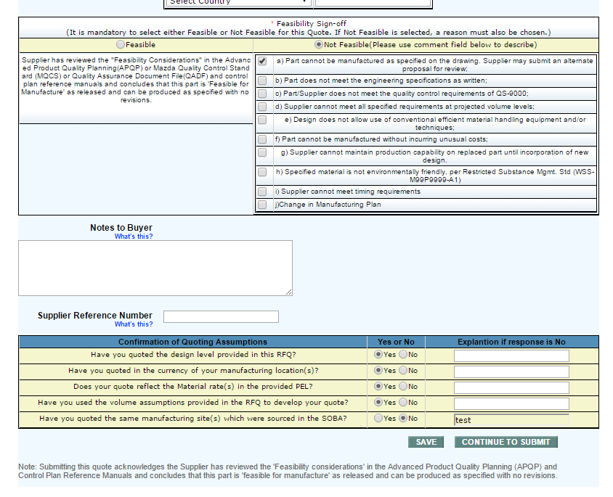
Then after reviewing one last time, click Submit Quote
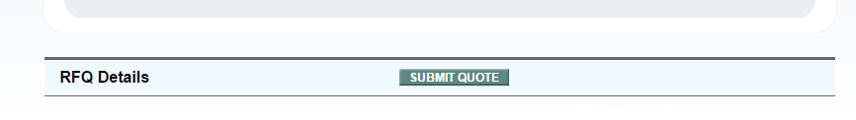
Once you receive the message below the process has been completed and the Quote is available for the buyer to review

